Serialization and Deserialization in Java
Serialization is a mechanism of converting the state of an object into a byte stream.
Deserialization is the reverse process where the byte stream is used to recreate the actual Java object in memory.
This mechanism is used to persist the object.
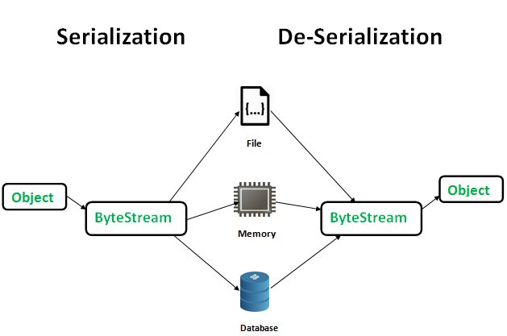
The byte stream created is platform independent. So, the object serialized on one platform can be deserialized on a different platform.
To make a Java object serializable we implement the java.io.Serializable interface.
The ObjectOutputStream class contains writeObject() method for serializing an Object.
public final void writeObject(Object obj) throws IOException
The ObjectInputStream class contains readObject() method for deserializing an object.
public final Object readObject() throws IOException, ClassNotFoundException

Advantages of Serialization
1. To save/persist state of an object.
2. To travel an object across a network.
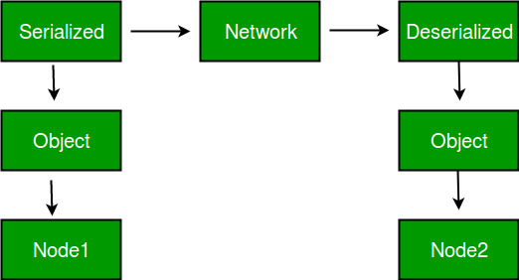
- Only the objects of those classes can be serialized which are implementing java.io.Serializable interface.
- Serializable is a marker interface (has no data member and method). It is used to “mark” java classes so that objects of these classes may get certain capability.
Other examples of marker interfaces are: - Cloneable and Remote.
Points to remember
- If a parent class has implemented Serializable interface, then child class doesn’t need to implement it but vice-versa is not true.
- Only non-static data members are saved via Serialization process.
- Static data members and transient data members are not saved via Serialization process.
- So, if we don’t want to save value of a non-static data member then make it transient.
- Constructor of object is never called when an object is deserialized.
- Associated objects must be implementing Serializable interface.
Example
class A implements Serializable {

// B also implements Serializable
// interface.
B ob=new B();
}
SerialVersionUID
If we have ever implemented Serializable interface, we have encounter this warning message
The serializable class xxx does not declare a static final serialVersionUID field of type long

what is serialVersionUID?
- The serialVersionUID is used as a version control in a Serializable class.
- If we do not explicitly declare a serialVersionUID, JVM will do it for us automatically, based on various aspects of our Serializable class, as described in the Java(TM) Object Serialization Specification.
Example
class A implements Serializable
{
private static final long serialVersionUID = 1L;
int i;
double j;
}
- serialVersionUID - default generated by JVM.
public class Manager1
{
public static void main(String[] args) throws Exception {
//doSerialization(); --→ 1
//doDeSerialization(); → 2
}

public static void doSerialization() throws Exception {
A a1 = new A();
a1.i = 10;
a1.j = 10.9;
FileOutputStream fout = new FileOutputStream("test.txt");
ObjectOutputStream out = new ObjectOutputStream(fout);
out.writeObject(a1);
out.flush();
out.close();
System.out.println("Serialization has done successfully!");

}

private static void doDeSerialization() throws Exception {
FileInputStream fin = new FileInputStream("test.txt");
ObjectInputStream in = new ObjectInputStream(fin);
A a1 = (A) in.readObject();
System.out.println(a1.i);
System.out.println(a1.j);
}
}
------------------------------
- in the class A - serialVersionUID - default generated by JVM
- In the above main method – doSerialization() will called.comments the other method [doDeSerialization ()]
- We will get the output as - Serialization has done successfully!
- That means serialization has done successfully with the default SerialVersionUID which has generated by JVM.
- Comment the doSerialization() method and uncomment the doDeSerialization() and run the program.
- It will print the output without any error message.
10 and 10.9
- Change the SerialVersionUID=11l to any integer value ending with l;
- And run the program

Exception in thread "main" java.io.InvalidClassException: com03.lara.A; local class incompatible: stream classdesc serialVersionUID = 1, local class serialVersionUID = 11
at java.io.ObjectInputStream.readObject(Unknown Source)
at com03.lara.Manager1.doDeSerialization(Manager1.java:37)
at com03.lara.Manager1.main(Manager1.java:18)

- The “InvalidClassException” will rise, because we write a serialization class with serialVersionUID “1L” but try to retrieve it back with updated serialization class, serialVersionUID “11L”.

- Note: The serialVersionUID have to match during the serialization and deserialization process.

What’s wrong with the default serialVersionUID?
If no serialVersionUID is declared, JVM will use its own algorithm to generate a default SerialVersionUID, we can check the algorithm here.
The default serialVersionUID computation is highly sensitive to class details and may vary from different JVM implementation, and result in an unexpected InvalidClassExceptions during the deserialization process.
Client / Server environment
– Client is using SUN’s JVM in Windows.
– Server is using JRockit in Linux.
➔ The client sends a serializable class with default generated serialVersionUID (e.g 123L) to the server over socket; the server may generate a different serialVersionUID (e.g 124L) during deserialization process, and raises an unexpected InvalidClassExceptions.
File / Database environment
– App #1 is using SUN’s JVM in Windows.
– App #2 is using JRockit in Linux.
- Serialization has allowed saving into a file or database. App #1 stores a serializable class into database by default generated serialVersionUID (e.g 123L), while App #2 may generate a different serialVersionUID (e.g 124L) during deserialization process and raise an unexpected InvalidClassExceptions.
How to generate serialVersionUID ?
There are three ways to generate serialVersionUID for your serialization class.
1. serialver command
JDK has a build in command called “serialver” to generate the serialVersionUID automatically. In this example, you use “serialver” to generate a serialVersionUID for Address class.
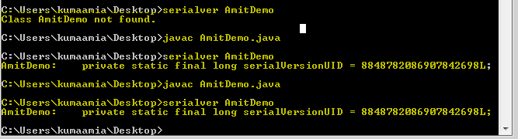
- Class should be implements serializable interface.
- Compile it and then use the serialver command as shown in the above screen shot.
2. Use Eclispe IDE
If you are using Eclipse, move your mouse over the serialization class.
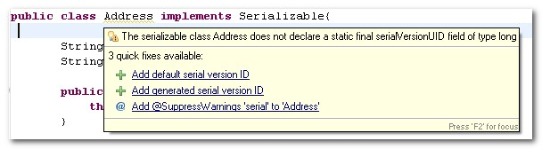
Anything we want
Just specify your own serialVersionUID , give a number and append an “L” behind.
private static final long serialVersionUID = 1L;
Conclusion
- SUN is highly recommended developers to declare the serialVersionUID in order to avoid the different JVM issue listed above

